Choose ONE of the five options below, and complete the SOAPSTone chart you were given in class.

OPTION 1: *Time*: May 29, 2017



OPTION 2: *The New Yorker*: January 18, 2018

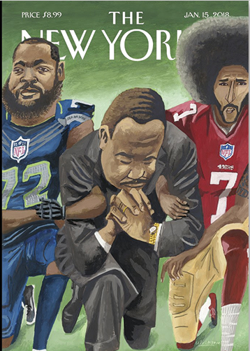

OPTION 3: *The New Yorker*: July 2, 2018

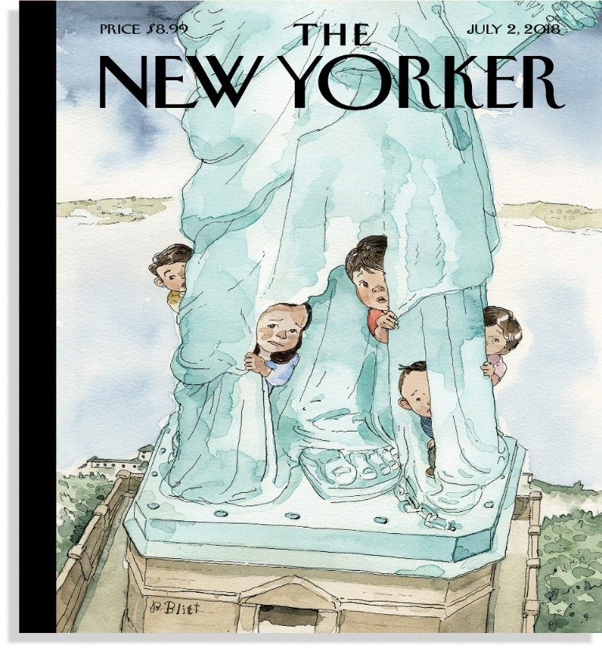

OPTION 4: *Time*: September 19, 2011



OPTION 5: *The New Yorker*: June 9 and June 16, 2008

